October 22, 2020
Ref: IIH/MD/2020/10/002
His Excellency,
The Executive Governor of Kwara State,
Government House,
Ahmadu Bello Way,
GRA, Ilorin, Kwara State.
Dear Sir,
ILORIN INNOVATION HUB PLAN & TENTATIVE CALENDAR
SN | Activity | Date
1 | Website & Social Media Launch
2 | Webinar: Building a Budding Tech Ecosystem in a Small City
3 | Open entries for 2021 Cohort 1

On your approval these members will be communicated and a schedule of duties will be submitted to your office.
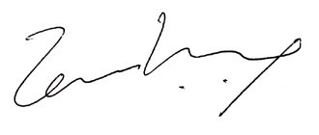

Temi Kolawole
MD Ilorin Innovation Hub

